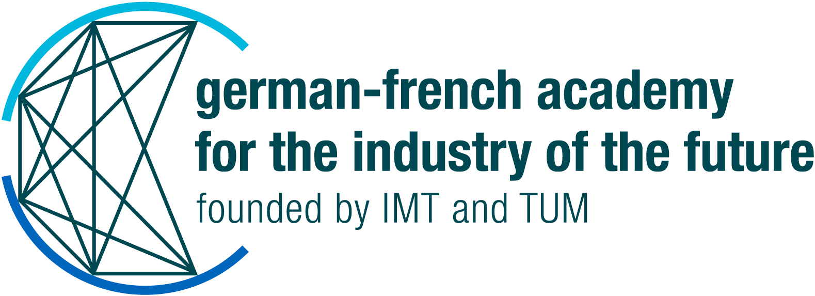
CALL FOR PROPOSALS 2023
SEED PROJECT APPLICATION TEMPLATE

Smart technologies ensuring secure operations in Industry

- Acronym and title of the project

xx

Keywords / Application areas

xx

- Applicants

TUM |  | IMT
Principal investigators |  | Principal investigators
Name |  | Name
Institute |  | Institute
E-mail |  | E-mail
Other contact person in charge of the project |  | Other contact person in charge of the project
Name |  | Name
Institute |  | Institute
Function in the project |  | Function in the project
E-mail |  | E-mail

Please provide a short description of the scientific expertise of the research tandem. (complementarity, joint experience in other projects, etc.)
xx

- Other partners

Please mention if other partners will be committed in the project. (associated researchers, industrial partners, start-ups)

xx

- Project outline (2 pages)

Keep in mind that your proposals must be placed in a context of cybersecurity crisis resolution or prevention, enhancing Industrial Security through Intelligent Technologies.

Short summary and central question

xx

Overview of the state-of-the-art

xx

Objectives of the project

Expected outcomes of the seed phase can be:
- a White Paper or a position paper, and/or other joint publications,
- a fully detailed proposal towards third-party funding (e.g.: Horizon Europe or ANR-DFG call),
- a scientific workshop or conference, summer or winter schools, or a dedicated event to share the outcomes and know-how to the community,
- a proof of concept, prototype or demo,
- a design of a new methodology.

xx

Expected impact on academia, industry and society

xx

5. Project structure and timetable (1 page)

Work packages & Deliverables

xx

Timetable & Milestones

xx

Human resources / Equipment / Consumables

xx

Budget planning
Please outline the planned expenses in tabular form and note the regulations for financing (see appendix).

xx

5. Further development (½ page)

Scale-up potential of the project and possible future actions beyond the seed phase

xx

Perspectives for applying for third-party funding

xx

Perspectives for new collaborations

xx

Signature(s) of the author(s):

