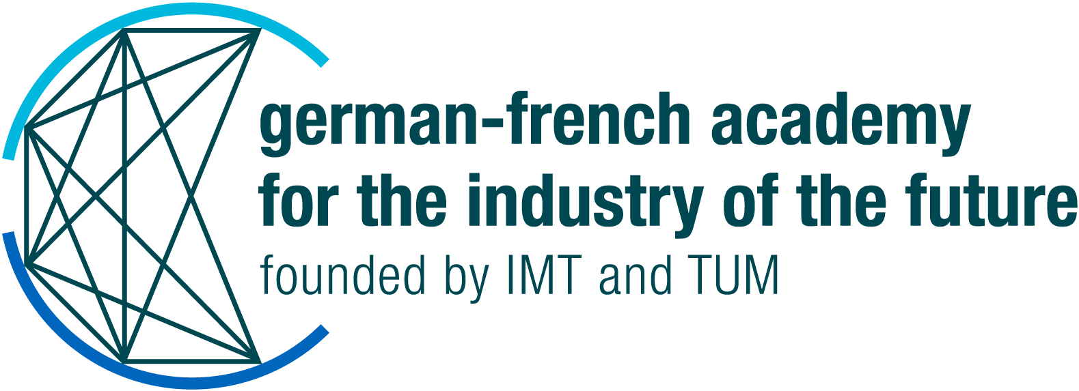
CALL FOR APPLICATIONS 2023
on Researchers’ Mobilité
APPLICATION TEMPLATE

Applicants

TUM |  | IMT
Name |  | Name
Institute |  | Institute
E-mail |  | E-mail
Nationality |  | Nationality
Current research  institution |  | Current research  institution
Host institution in the partner country |  | Host institution
Date of thesis defense  (for doctoral students: planed) |  | Date of thesis defense  (for doctoral students: planed)
Supervisor/Superior of the applicant |  | Supervisor/Superior of the applicant

Please provide a short description of the scientific expertise of the research tandem. (complementarity, joint experience in other projects, etc. and please state the GFA project(s) that you or your research group was involved in)

xx

Other partners

Please mention if other partners will be committed in the exchange. (associated researchers, industrial partners, start-ups)

xx

Objectives and framework

Objectives of the exchange

Expected outcomes of the exchange:
- joint publications,
- joint project proposal,
- a scientific workshop or conference, summer or winter schools, or a dedicated event to share the outcomes and know-how to the community.

xx

Expected impact in the research field (also long-term)

xx

Desired duration of the exchange

xx

Complementary funding requested at (if applicable):

xx

Signature(s) of the author(s):

I hereby confirm my support for this application.

Signature(s) of the Supervisor(s):

